Worksheet No. - 3

Student Name: Sujal Dhiman UID: 25MCA20186
Branch: MCA Section/Group: 1A
Semester: 2nd Date of Performance: 27/01/2026 Subject Name: TECHNICAL TRAINING Subject Code:25CAP-652

Aim/Overview of the practical:
To implement conditional decision-making logic in PostgreSQL using IF–ELSE constructs and CASE expressions for classification, validation, and rule-based data processing.
Objective:
- To understand conditional execution in SQL
- To implement decision-making logic using CASE expressions
- To simulate real-world rule validation scenarios
- To classify data based on multiple conditions
- To strengthen SQL logic skills required in interviews and backend systems

Input/Apparatus Used:
  - PostgresSQL
  - pgAdmin

Procedure/Algorithm/Code :
create table student (
student_id INT,
student_name VARCHAR(50),
marks INT
);

insert into student values
(1, 'Amit', 95),
(2, 'Riya', 82),
(3, 'Rahul', 68),
(4, 'Sneha', 55),
(5, 'Karan', 40),
(6, 'Neha', 90);

select student_name, marks,
case
when marks >= 90 then 'Excellent'
when marks between 75 and 89 then 'Good'
when marks between 50 and 74 then 'Average'
else 'Poor'
end as performance
from student;

alter table student
add column status VARCHAR(25);

update student
set status =
case
when marks >= 75 then 'Approved'
when marks between 50 and 74 then 'Needs Improvement'
else 'Not Approved'
end;

select * from student;

do $$
declare
student_marks int := 68;
begin
if student_marks >= 90 then
raise notice 'Grade: Excellent';
elsif student_marks >= 75 then
raise notice 'Grade: Good';
elsif student_marks >= 50 then
raise notice 'Grade: Average';
else
raise notice 'Grade: Poor';
end if;
end $$;

select
student_name,
marks,
status
from student
order by
case
when marks >= 90 then 1
when marks between 75 and 89 then 2
when marks between 50 and 74 then 3
else 4
end;

Output:

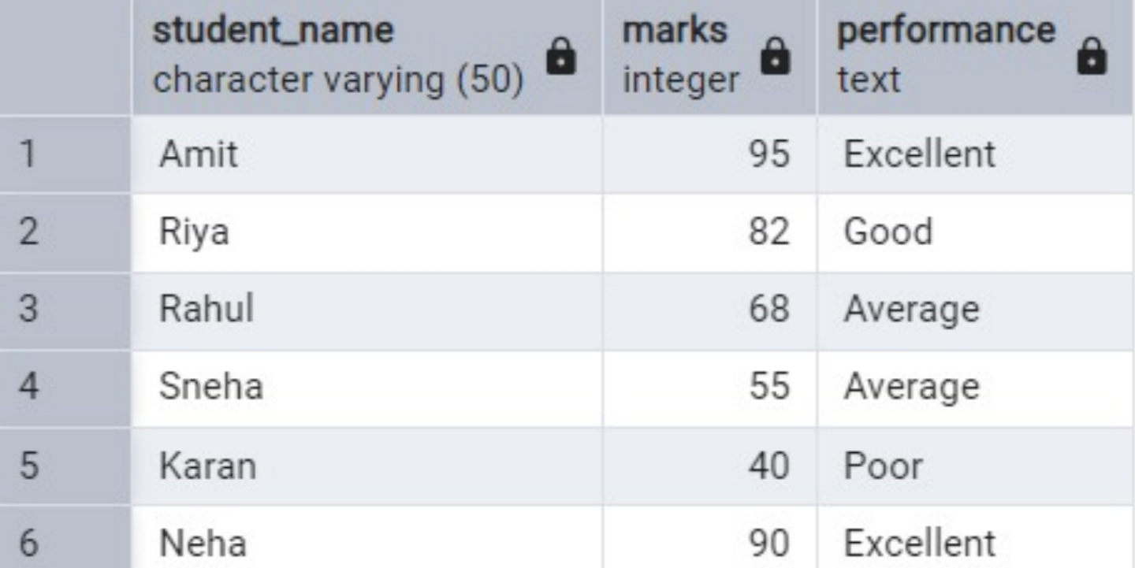

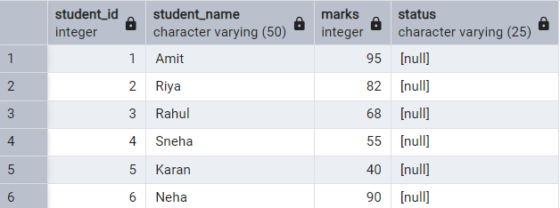

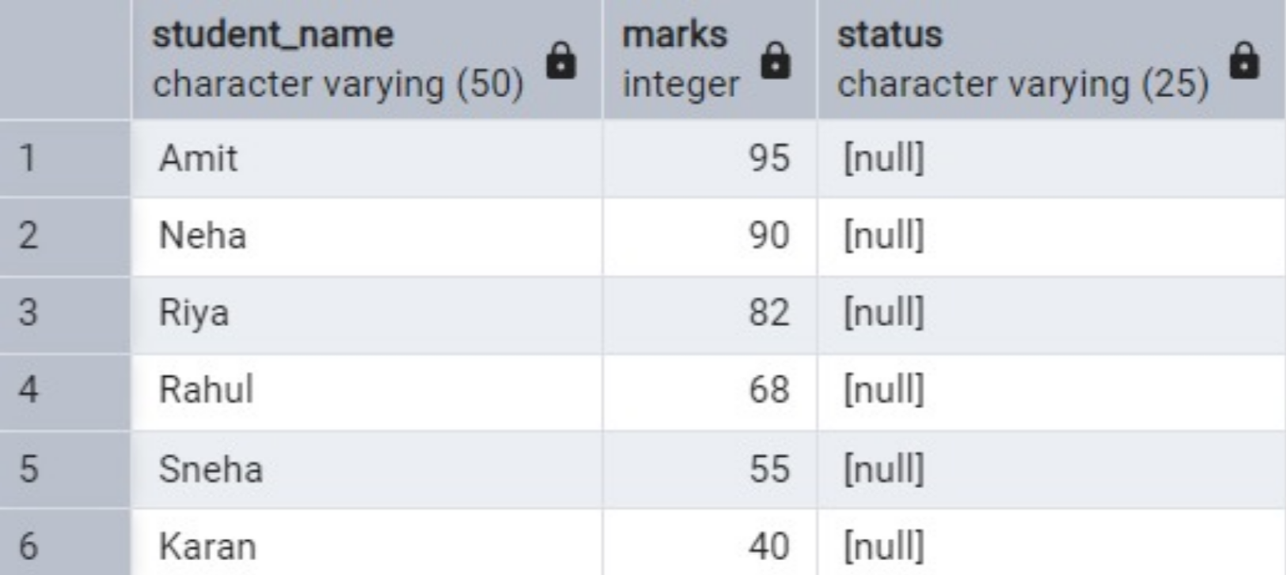

Learning outcomes (What I have learnt):
- Understand and apply CASE expressions in SQL for classifying data based on multiple conditions.
- Implement conditional logic inside UPDATE statements to automate decision-making at the database level.
- Use IF–ELSE control structures in PL/pgSQL to perform procedural and rule-based data validation.
- Design real-world classification systems such as grading or performance evaluation using conditional logic.
- Apply CASE expressions for custom sorting and reporting, improving query flexibility for analytical and dashboard use.

